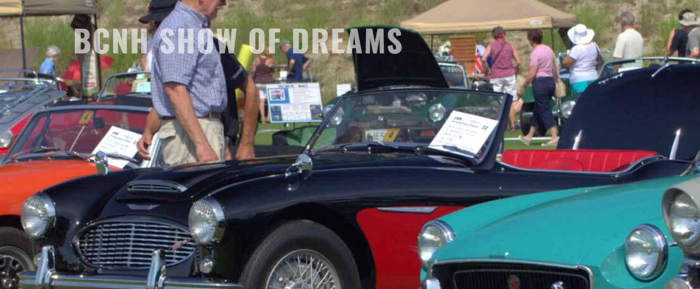
Show of Dreams
Saturday, July 27, 10am-3pm
Alvirne Hills House Field
Hudson, NH
British Cars of New Hampshire announces the 27th Annual Show of Dreams will benefit The New Hampshire Food Bank.
This year the featured Marque is Austin-Healey.
For more information about the show and to register click the link below!

ENTRY FEE: $30 ON OR BEFORE 7/9/2024, AFTER 7/9/2024 $40, ADDITIONAL CARS REGISTERED BY THE SAME OWNER - $10/CAR.

Show of Dreams Registration - Online - British Cars of New Hampshire (bcnh.org)

