BUGEYE PROJECT FOR SALE

HEALTH FORCES SALE OF UNFINISHED DREAM RESTORATION PROJECT
Have a 1958 (green) and 1960 (white)
INCLUDING ONE HARDTOP AND ALL PARTS FOR BOTH. RELATED TOOLS INCLUDED.
Have both Heritage Certificates from British Motor Industry Heritage Trust.
The 60’s drivetrain runs well and is in good condition, minimal bodywork needed.
New radiator and all new hoses, new generator, and starter, including new coil.
New distributor cap and wiring. New gas tank and feed line to pump. Replaced entire exhaust system. Newly rebuilt SU carbs. New fan belts, and much more,,,
The 58 needs bodywork and has new tires on original rims. It is mounted on a rotisserie (included in the sale). The drivetrain is in good condition. The engine was professionally rebuilt February 2024 (no expense spared), “0” running time. Transmission rebuilt, new generator, new starter, newly rebuilt carbs and new fuel pump. Rotating engine stand included.
Both are stored in a Rhode Island barn with easy access for shipping.
This is a great project for any Froggy Enthusiast. Only needing bodywork, painting, and assembly.
FOR INFORMATION CALL FRANK 401-767-6700
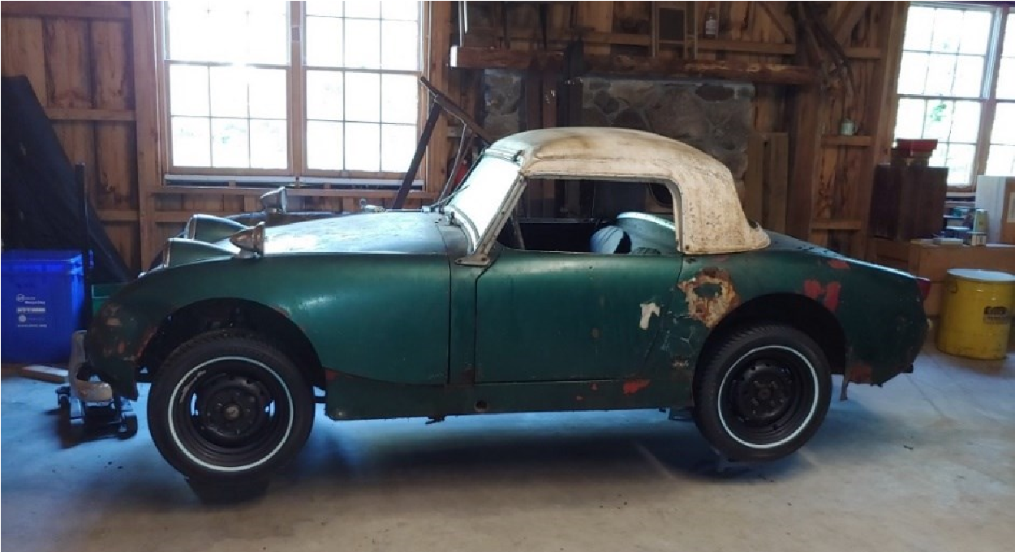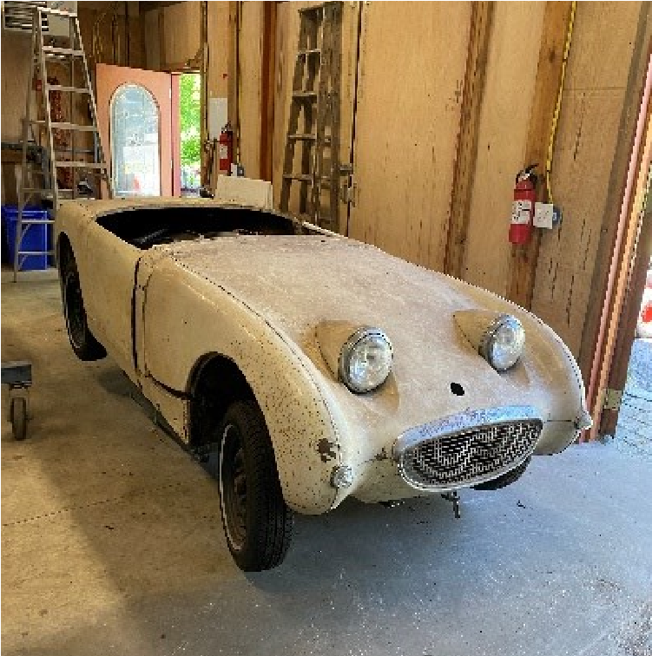
1958 1960
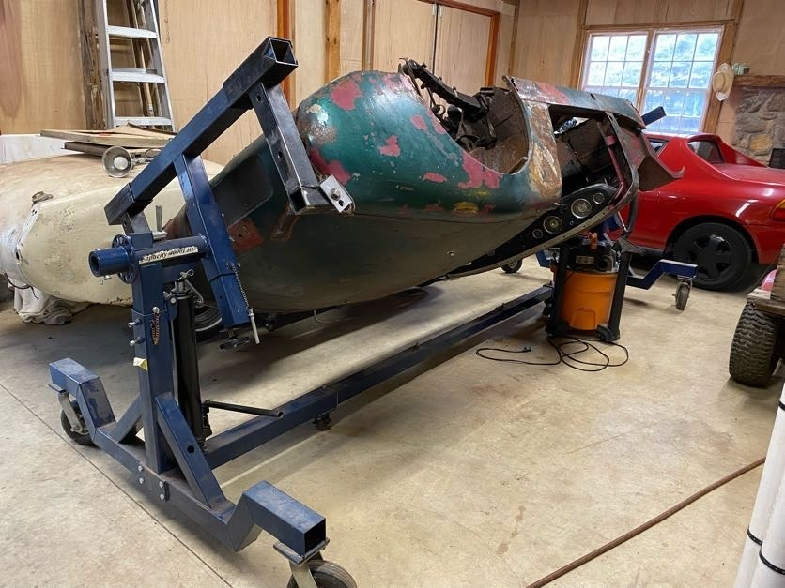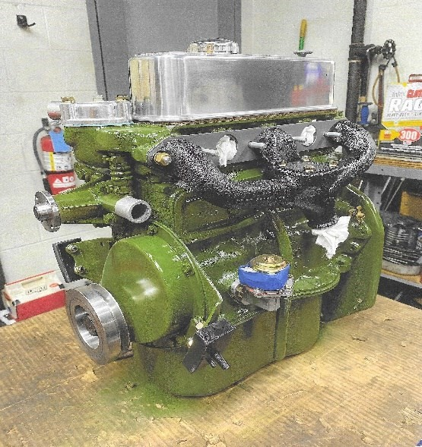
1958 mounted on rotisserie Newly rebuilt engine
New carbs not shown
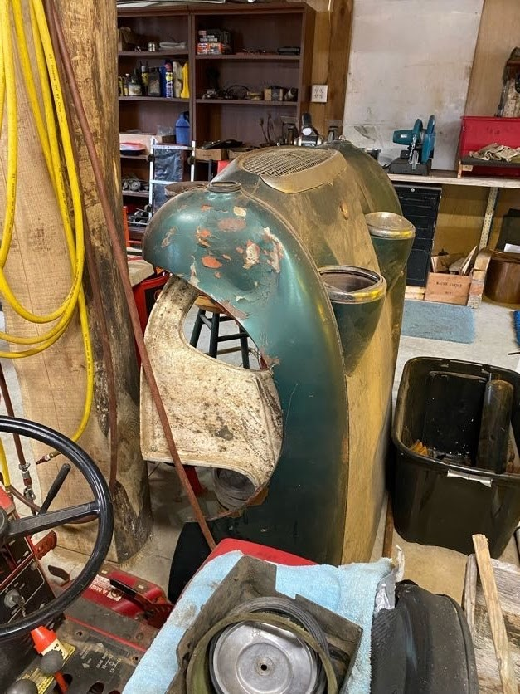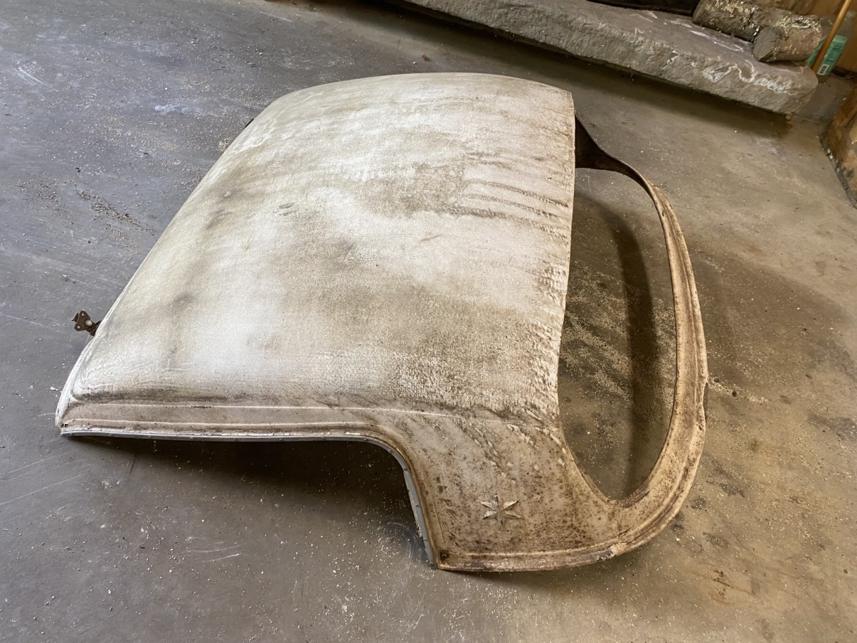
bonnets & doors in good shape Hard top in fair shape
