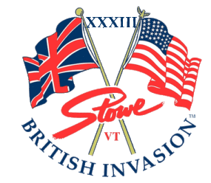
September 20-22, 2024
British Invasion
Stowe, Vermont
The British Invasion is a British lifestyle event that started “over a pint of ale” in Stowe, Vermont, in 1990. It is a three-day event that includes “all things British”, with primary focus on classic British motorcars. Beautiful Stowe, Vermont, hosts this dazzling collection of classic British Motorcars every year in September. The British Invasion is the largest all British motorcar show in the United States annually attracting over 600 British motorcars from the US and Canada. We look forward to celebrating our 32nd year with you this September!
Mark your calendar for British Invasion XXXIII, September 20-22 in beautiful Stowe, Vermont.
This year’s featured marques are Austin-Healey, MG, Rolls-Royce & Bentley.
They have been working on expanding British Invasion 2024 by adding Vermont Arts & Crafts as a New section, with the hope of attracting more attendees on Saturday and Sunday. Several properties in Stowe have changed hands since last year, so we encourage you to book accommodations early.
Register — The British Invasion

