Sunday, June 2, - 10am-4pm
British by the Sea
Harkness Memorial State Park 275 Great Neck Rd - Waterford, CT
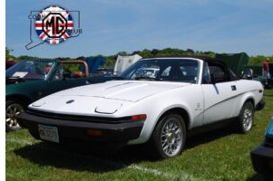
The CT MG Club’s British by the Sea annual gathering is held at Harkness Memorial State Park in Waterford CT on the North shore of Long Island Sound.
This year’s marque of the year is the Triumph TR7 & TR8!
BBTS is a popular vote, fun event, with etched glass mugs being presented as awards. We will have 32+ Classes, displayed on our 4-acre field. We want to encourage ALL British car, truck, and motorcycle owners and enthusiasts to attend and have an enjoyable time. Whether your vehicle is in pristine condition, or a daily driver, sparkling paint, and chrome or with “Barn Fresh” patina, it deserves to be part of the event and on the display field.

BBTS REGISTRATION.pdf (ctmgclub.com)

