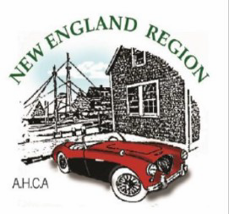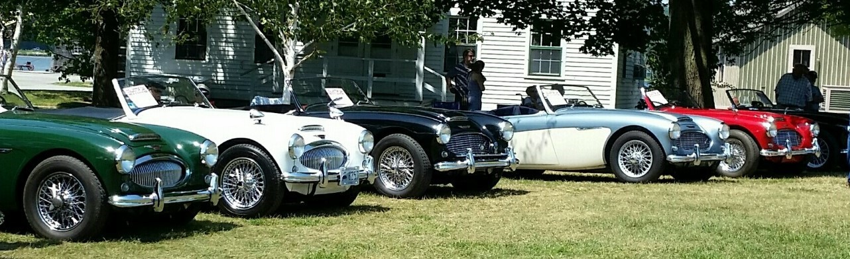
Healey Exhaust Notes
May 2016
Healey’s On The Green, Mystic Seaport, CT
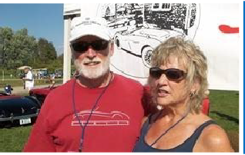

President’s Letter
by Bob Britton

As the old saying goes “April showers brings May flowers” and the start of Healey driving season. I was finally able to get my BJ7 out for a trip over to Classic Motor Sports in Candia, NH for their monthly Cars and Coffee event. It was a beautiful sunny day to drive the Healey. As temps were only in the high 30’s in the morning
I departed home with the top up. But by late morning the temps were approaching the 60’s so with my hoodie on it was tops down for the ride home. What an assortment of cars showed up. Besides a few big Healey’s driven by club members there were several vintage Porsches, a pristine BMW 2002 and Datsun 260Z, a couple of Cobra’s, an assortment of Triumphs and MG’s, a very nice Mercedes 190SL and an assortment of other classic cars. It was like a mini car show. And then there is the collection of cars inside, mostly there for winter storage. It was nice to meet new members Kevin and Ellen Murphy at the event. Ellen is the proud owner of an unrestored, low mileage BJ8 that belonged to her father who was the original owner. Her dad only let her drive it once when she was 17 so I am sure she and Kevin will be looking forward to future adventures in this very special car.

I trust you all received your complimentary AHC-NE windshield decal in the mail. Don’t forget to put it on your windshield to let everyone know you are a member of this club. If you would like to order extra’s they are available for $2 each which includes postage and mailing. See the notice on page 12of this issue.

Plans for Summit 2016 are shaping up nicely so if you are planning to attend don’t forget that the early bird registrations are due by May 15th. So, for all you procrastinators now is the time to get your registrations filled out and sent in before the deadline. Just one of the highlights of the event will be Ben and Jerry (well,
maybe not the real guys) scooping ice cream during the Ice Cream Social to be held in conjunction with the very competitive Valve Cover Racing. You won’t want to miss this.

Last month I mentioned that the club gave a check to the JDRF in the amount of $1500 which its members raised last year. What I forgot to mention was this donation was made in the memory of Jim Smith, who was an avid supporter of the JDRF charity and a long time active member of the AHC-NE.

And finally there are several great club events you can attend this month so get your Healey out of the garage or barn, gas it up, put the top down and head out on the road. Remember, while the cars are what bring us all together the true enjoyment of club membership is the camaraderie that our common interest in these wonderful classic cars provides.

See you on the road soon, Bob Britton
President

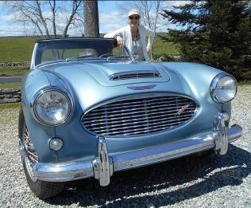

CONTACT INFORMATION
Club Officers & Area Coordinators

CONTACT | NAME | PHONE | E-MAIL
President | Bob Britton | 603-381-3158 | healeybj7@hotmail.com
Vice President | Jud Perkins | 860-204-9168 | judperk@comcast.net
Secretary & Webmaster | Pete Sturtevant | 774-284-1212 | healeybn4@comcast.net
Treasurer & Member- ship | Carl & Amy Carvell | 401-322-7741 | cgcarvell@gmail.com
Publisher/Editor | Dutcha Slieker-Hersant | 860-859-7476 | HealeyDutcha@gmail.com
National Delegate | Steve Bell | 508-947-6499 | scbell1@comcast.net
Technical Advisor | Ted Stanton | 860-535-9184 | healey@snet.net
AREA Coordinators | NAME | PHONE | EMAIL
Upstate NY | Dennis Broughel | 518-858-8877 | brougheldp@gmail.com
SW/CT & Metro NYC | Rudi Markl | 914-481-8555 | rmarkl@optonline.net
Northern CT | Len Bach | 860-875-8855 | SummitM9@aol.com
SoEastern CT | Ted Stanton | 860-535-9184 | healey@snet.net
Eastern MA & RI | Steve Bell | 508-947-6499 | scbell1@comcast.net
Western MA | Bob Bender | 413-684-3934 | Rbender1@berkshire.rr.com
VT | Bill Berg | 802-442-2777 | jmdberg@comcast.net
NH | Bob Abbott | 603-433-9544 | healeybj7@aol.com
Maine | Bill Hayes | 207-636-2515 | bhayes@metrocast.net

Slowly but surely the spring weather is improving. Time to check the fluids, wipe off any dust and take that Healey for a spin.
This past Saturday was a perfect cruising day and with out of town company to entertain, what better to do then take the BT7 for a spin?
The Big One, companion and I had a lovely drive and returned feeling reborn!
Don’t wait for the perfect day – any day is a good day to take your Healey out of the garage. Remember, we need to keep them on the road!

CANCELLATION NOTICE : For those w ho had planned to attend the Clark Art Institute Meet scheduled for May 14, 2016 , please note that it has been cancelled. Bob & Betty Bender thank you for your understanding.

If you have anything you would like to share with other members, please submit your articles in Word document format by the 25th day of each month for inclusion in the next month’s edition.

Dutcha Slieker-Hersant, Editor

HealeyDutcha@gmail.com - Cell phone 860-859-7476

Healey Exhaust Notes Page 2 May 2016

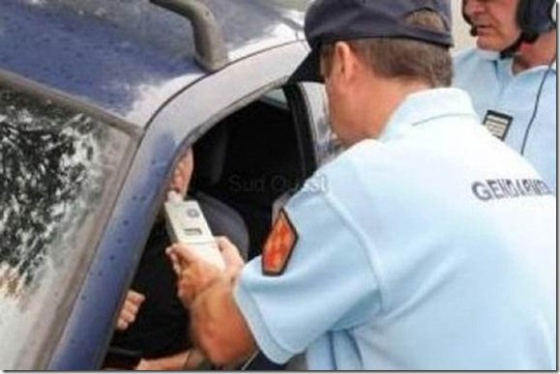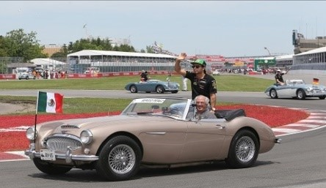

Have a great Healey story?
In talking with Club members, I find lots of interesting stories…
why I bought my car, how long I’ve had my car, once upon a time I broke down in and how I got home, I’ve traveled to with my Healey, the most beautiful Healey I’ve ever seen was, racing my Healey, my favorite Lucas electrical story, and the list goes on endlessly.
How about sharing a few of these stories with us? Really simple, write an email with your story and send it to Dutcha Slieker-Hersant, the editor of Exhaust Notes at healeydutcha@gmail.com. Photos to complement the story would be great but not essential.

Jud Perkins
This one might make you laugh!
Study the picture first and then read the story.

This actually happened to an Englishman in France who was totally drunk.
A French policeman stops the Englishman's car and asks if he has been drinking.
With great difficulty, the Englishman admits that he has been drinking all day, that his daughter got married
that morning, and that he drank champagne and a few bottles of wine at the reception,
and many single malts scotches thereafter.
Quite upset, the policeman proceeds to alcohol-test (breath test) the Englishman and verifies that he is indeed totally sloshed.
He asks the Englishman if he knows why, under French Law, he is going to be arrested. The Englishman answers with a bit of humor,
"No sir, I do not! But while we're asking questions, do you realize that this is a British car

VP Ramblin’
by Jud Perkins

Strictly Business
Summary of AHCA NE 2016 Business & Planning Meeting
April 2nd Bentley’s – Sturbridge MA

AHCA NE Planning Meeting April 2nd – Sturbridge MA

Larry Swift, Nick Zarkades, Steve Bell, Amy and Carl Carvel, Judi and Ted Stanton, Bob Britton and Linda Hakala, Dutcha Slieker-Hersant, Jud Perkins and Pat, Denny Broughel and Cheryl Ames,
Bill Berg, David Shushan, Rick Neville, Steve Detra, Pete Sturtevant

- Bob Introduced new member David Shushan.

- Carl approved the minutes from the February meeting

Membership/Treasurers Report:
  - Carl’s Treasurer Report: $21k in the checking account
  - AHCA NE 2016 membership currently - 305.
  - 4 new members in the past 30 days (March).
  - Carl to send out final notice for 2016 renewals

Dutcha’s Newsletters update:
  - Please send event and interesting pictures to Dutcha.
Check out Rafe’s and George Greider websites for historical pictures.
  - Dutcha is looking to create in the newsletter the birthday and anniversary corner.

- Advertising in the newsletter:
  - Commercial rates from $10 to $50 per month or $80 to $400 per year for full page and include to the website.
  - Classified Ads free to members for parts, cars, and services.
  - Feature local restorers with a vendor profile. A free profile for first car services.
  - Sports Car Services is our first vendor 1/8 page add.
  - Newsletter distribution 20 email corrections.
  - 5 members do not have computers.

- Bob Introduced Denny Broughel as the new club VP for 2017.

Website update:
- Members agree to keep old website for six months to transfer.
  - (Since the meeting Deb Katz has confirmed that the old web site will not allow a six month renewal, and only 1 year for $150) I have told Deb to cancel the old account.
  - Pete provided the website statistics on the separate file

Charity Update:
- For 2016 BU Bionic Pancreas center will be our official charity.
  - Raise money. Donation jar at Carlisle, and a Stand up sign which Nick will create and handout for BU Bionic Pancreas
  - Jud to check out and investigate the details and primary contact for this charity.

- Pete purposed that we give an extra AHCA NE extra decal for all in attendance, which was approved by the members in attendance.

- All members approved purchasing 50 grille badges and for approximately $1k. Nick has pre-order com- mitment s for $30 badges which already covers the total cost of the badges.

Events for 2016:
  - Summit 2016
    - Black Bear Lodge separate wing for AHCA NE
    - Ben & Jerry's Ice Cream Social
    - Sponsorship. Sports Car Services $500, Hagerty $300, VB $150, British Wiring $150.
    - John Nikas and Bentley.
    - Check with AAA Northern NE - Larry Swift.
    - Nick Event Program, Full Page advertisements.
    - July 15th deadline for registrations.
    - Chinese auction 25 items thus far. Larry will work with Steve Bell.
    - The Car Show will be at Orvis in Manchester VT. Advertise in the local Manchester newspaper.
    - Fred Dabney to provide insurance details for Summit 2016.
    - Amy to check our local VT attractions working with the Bergs.

- Barbara Weismen represented JDRF for the presentation of the $1500 check in memory of Jim Smith. The money goes directly to research. AHCA NE three club member have children with direct connections to JDRF including: the Carvell's, Bach's, Jud Perkins

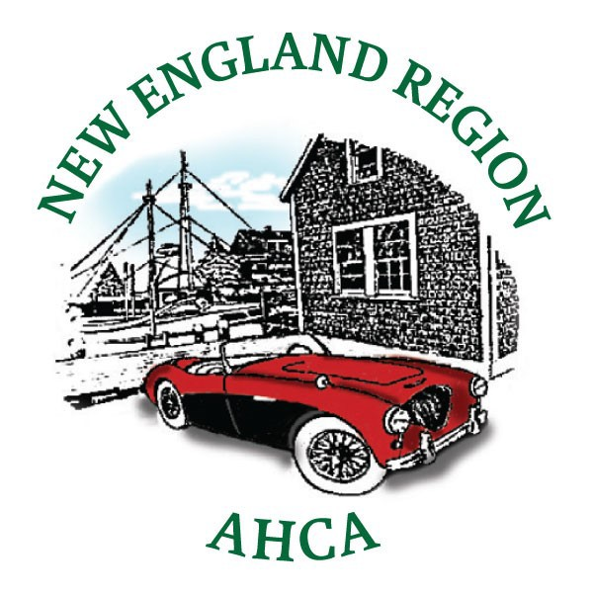

WELCOME To Our New Members . . . .
Alas, this month there aren’t any new members to welcome.

Thought for this month: let’s all print a copy of the Join Us Form on the last page of this newsletter and carry it in our Healey. When we encounter local/regional Healey owners at car shows & other events this summer, we will be prepared and maybe we can grow the membership .
Celebration Corner . . . .

Do you have a birthday, a personal or club anniversary this month that you wish to share with your Healey friends? Drop us a note and we will announce your special celebration here.

Austin Healey Club of New England 2016 Calendar of Events
Events in RED are AHC of NE sponsored events

DATE | EVENT | LOCATION | CONTACT
Sat. May 14 | Clark Art Museum Tour | Williamstown, MA | EVENT IS CANCELLED
Wed-Sat May 18-21 | Carlisle Import & Kit Show | Carlisle, PA | Steve Bell scbell1@comcast.net
Sat. May 28  09-11:00 AM | Tech Session :  Meet Wayne Carini of Chasing Classic Cars | F40 Motor Sports  464 Portland-Cobalt Road  Portland CT 06480 | Ted Stanton healey@snet.net
Sun. June 5  09:00 AM | British By The Sea Car Show | Harkness State Park Waterford, CT 06385 | Ted Stanton healey@snet.net
Thurs-Sun June 9-12 | British Motorcar Festival | Colt State Park Bristol, RI | Peter Sturtevant healeybn4@comcast.net
Sun. June 12 Time TBD | Rallye For A Cure | Jaguar Hartford, Hartford, CT | Jud Perkins judperk@comcast.net
Sat June 18  12 noon | Winery & Brewery Tour | Hoosick, NY | Denny Broughel brougheldp@gmail.com 518-663-8879
Sun. June 26 | British Car Day | Larz Anderson Museum 15 Newton St Brookline MA | www.larzanderson.org
Sat. July 9 | Castle in the Cloud Car Show | Ludnow Estate  455 Old Mountain Rd Moultonborough, NH | Don Margeson donmrgsn@yahoo.com www.castleintheclouds.org
Sat. July 16 | Tour to the Rhinebeck Aerodome | Old Rhinebeck Aerodome 9 Norton Road  Red Hook NY 12571 | Jud Perkins judperk@comcast.net 860-204-9168
Sat. July 23 10AM-3PM | 20th Show of Dreams BCNH | Alvirne Hill House 211 Derry Rd Hudson, NH | Diana Stanley dstan1950@gmail.com 603-568-9795
Wed-Sun July 27-31 | SUMMIT 2016 | Stratton Mountain Resort Stratton, VT | Linda Hakala linda.m.hakala@gmail.com 603-398-4421

Continued on next page

Austin Healey Club of New England 2016 Calendar of Events
Events in RED are AHC of NE sponsored events

DATE | EVENT | LOCATION | CONTACT
Sat. Aug 6 | Hemmings Sports & Exotic Car Show | Saratoga Springs, NY | www.hemmings.com/events
Wed-Sat Aug 10-13 | Encounter AHSTC | Sheraton Wilmington South New Castle, DE | www.Austin-Healey-STC.org
Sat. Aug 20 Rain Date: Aug 21 | Thimble Island Cruise and Luncheon  09:30 AM - 2:00 PM | Thimble Island Cruise Co 4 Indian Point Rd Stoney Creek, CT | David Snetro david.snetro@morganstanley.com 203-209-2217
Fri-Sun Sept 16-18 | 26th British Invasion | Town & Country Inn Stowe, VT | Bob Britton healeybj7@hotmail.com 603-381-3158
Sat Sept 24 time TBD | Essex CT Tour | Essex, CT | Jud Perkins judperk@comcast.net 860-204-9168
Fri-Sun Oct 21-23 | Healey Weekend | Plymouth Sands Motel Plymouth, MA | Steve Bell scbell1@comcast.net 508-647-6499
Fri Dec 9 | AHC-NE Christmas Party | Old Sturbridge Village Sturbridge, MA | Len Bach summitm9@aol.com

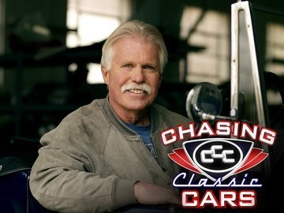Don’t miss this great opportunity to meet Wayne Carini, of Chasing Classic Cars fame!
Tech Session at Wayne Carini’s Motor Sports May 28, 2016 09:00 - 11:00 AM

Saturday, May 28th, we’ll meet at Wayne’s place at 9:00 AM sharp for a 2 hour tour of his fantastic shop with Wayne as a tour guide. He should have some great stories of his run of the Mille Miglia the week before. He shop is located at 464 Portland-Cobalt Rd
(Route 17), Portland, CT.
To prepare yourself for this great tour, check out his website : http://f40.com

We’ll meet at Campagna’s Restaurant at 151 Marlborough St.(also Route 17) in Portland
at 8:30 and leave at 8:55 for a short run to Wayne’s for those who want to arrive as a group. Otherwise, meet us at Wayne’s.

We must vacate by 11: 00 as he needs to be in Massachusetts in the afternoon.
We’ll go back to Campagna’s for lunch for those who want to grab a bite of lunch.
It’s a Holiday weekend but if you can squeeze in a few hours, it should be a lot of fun. Please email me at healey@snet.net to let me know if you plan on coming.

Ted Stanton

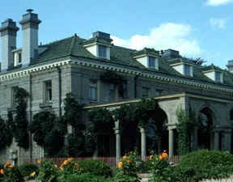
BRITISH BY THE SEA 2016
June 5, 2016 — 09:00 AM
Harkness Park, Waterford CT

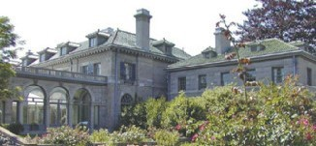
BRITISH BY THE SEA 2016

The "BRITISH BY THE SEA” is a fun gathering of people who own and appreciate British Vehicles. Sunday, June 5th marks the 29th annual BRITISH BY THE SEA event. It is always a great time and we usually get about 20 or 25 Healeys. Bring a picnic lunch or buy on site and be prepared to see hundreds of quirky English cars (and owners).

As usual we’ll meet at Fort Trumbull at 90 Walbach Street New London, CT 06320 at 9:00 AM for coffee then travel the 10 minutes together to arrive at the scenic 240 acre Harkness Memorial State Park in Waterford CT, by 10:00AM.
The address for Harkness State Park is 275 Great Neck Rd. Waterford, CT 06385.
Contact Steve & Annie Wincze of the CT-MG club at 860-693-4249 or email MGTD52@comcast.net for a registration form to pre-register at $ 15 or pay $20 at the gate.

The CT MG Club donates a large amount of our proceeds from BBTS to the Park to help restore the “Eolia” Gardens to their original grandeur. In addition, we provide “people power” over a few week ends to help plant. "BRITISH BY THE SEA" is not a judged show, although we do present etched glass mug awards to vehicles selected by popular vote.

Please email me at healey@snet.net to let me know if you plan on coming.
If you have a problem getting there, call my cell at 203 605 4172.

Ted Stanton

Carlisle Import & Performance Car Show — Carlisle, PA
May 18-21, 2016

Carlisle 2016, May 18—21

Plans are well underway for the New England Region to be well represented at this years British, Import, Kit car and Performance Car show at the Carlisle Fairgrounds in Carlisle, PA.

Eight club members are attending and two guests, one from Australia and one from Holland, will be on hand to support club membership, offer advice and buy & sell Healey parts.

Currently, we understand that hotel space is extremely hard to find. We recommend you make your arrangements asap.

If anyone is interested in attending, please contact Steve Bell 508-947-6499.
Sprite Parts Wanted:

Tony Bennetto of the Bugeye Barn in Melbourne, Australia will be here in May on his annual Sprite parts buying tour. Tony will be traveling from Boston to Syracuse and then on to Carlisle, PA looking to buy the following items: Bugeye bonnets and bonnet stays, windshield pillars, Bugeye heater boxes and blower motors, 1275 Engines, late model ribcase gearboxes, Bugeye steering columns and steering wheels, Bugeye gauges, OEM steel wheels, side curtains, door pockets, front disc brake set-ups, Bugeye grills, differentials and memorabilia. He will be on a tight schedule and is willing to buy in advance of his arrival on May 16th. He will buy in quantity at reasonable prices. Pictures are helpful in negotiating prices.

If you have items of interest please contact
Steve Bell, scbell1@comcast.net,
with an item list.
We are looking for ……

Innocenti Spider Parts sought :

Any club member who may have some knowledge of the whereabouts of any Innocenti Spider carcasses is asked to con- tact Steve Bell.

Steve Bell, scbell1@comcast.net,

Donations Sought For Summit

Each year Summit offsets some of the operation expenses by running what is called a Chinese Auction. Members purchase tickets and place them in the containers attached to items they would like to bid on. These items come from various sources, including sponsors, businesses and club members. If you have an item you would like to donate to this event, please contact Steve Bell at scbell1@comcast.net. Items can be memorabilia, books, glassware, badges and parts that pertain to the Austin Healey marque. Donations will be recognized during the event by placing the donors name on placards that accompany the items on the auction table. We hope you are already making plans to join us at Stratton Mountain for this years SUMMIT event.

Steve Bell, scbell1@comcast.net,

Wine & Brewery Tour June 18, 2016
Hoosick, NY

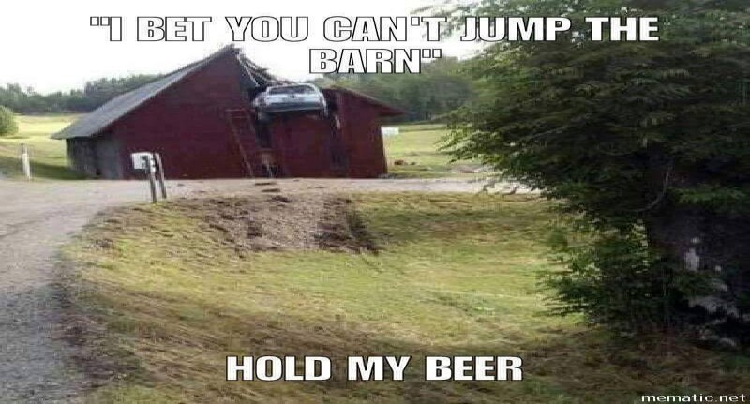WINE X 2 and BEER TOUR JUNE 18, 2016
Tired of going doing the same old scenic drive in your own region? Want to shake things up a little?
Join us for a fun Vinyard & Brewery Tour !

We will meet 12 NOON at the intersection of New York Route 7 & 22 in the town of Hoosick, NY. There is a Stewarts Convenience Store, 4700 New York 7 Hoosick, NY 12089 where you can rest, get a beverage and food, fill your tank, and use clean restrooms.

The first stop of the tour will be at the Amorici Farm & Winery
http://amoricivineyard.com/
which has just received some silver and bronze medals in international competition.
My own private sommelier (Bob Bender) has told me that their Marquette NOR 2014 was superb
with a fine taste of tannins and an oaky nose and is somewhat precocious.

Second on our tour will take us a short distance to the Victory View Winery
http://www.victoryviewvineyard.com/
(which has won several double gold medals at the Finger Lakes Wine Competitions), for a tour and tasting ($5.00 gets a wine-tasting plus you keep the wine glass)

Our third, and final stop, will be at the Browns Brewery
http://brownsbrewing.com/
in Hoosick Falls, NY where we will take a tour and have a sampling ($5.00 gets a flight of different beers plus a Browns pint glass to keep.

After the tour the taproom and restaurant will be open for your dining pleasure of good pub-type grub.

Following the tour there is a short drive back to our starting point for the ride home

Please drive safely on your way home—we do not want to leave any Healeys in the Barn...

RSVP by June 13, 2016
Denny Broughel brougheldp@gmail.com

Thompson Speedway …..
Need an extra decal …..?

You are invited to the 3rd Annual Vintage Motorsports Festival at Thompson Speedway Motorsports Park, on June 23-25. This event takes place on our historic 1.7 mile road course, and has quickly become the marquee event of the season for road racing at our facility - featuring 2 days of racing for over 200 vintage race cars ranging from pre-war through to the muscle cars of the 70's.

This year we are excited to be offering a British Car Corral on Friday, June 24. We are also offer- ing parade laps around the track for the first 30 car corral participants to sign up.

For more information about the event or to pur- chase tickets or car corral spots,
please visit our website. We look forward to seeing you in June!

Thompson Speedway Motorsports Park
205 East Thompson Road Thompson, CT 06277
W: www.thompsonspeedway.com
Recently all l club members were mailed a com- plimentary windshield decal pictured above iden- tifying their membership in the AHC-NE. If you want another windshield decal for your daily driv- er or extensive collection of Healey cars they are available for $2 each.

To purchase additional decals send a check payable to AHC-NE to:

Carl Carvell
12 Spray Rock Rd. Westerly, RI 02891
British Motorcar Festival 2016 Colt State Park, Bristol RI June 9-12, 201
British Motorcar Festival 2016

Colt State Park, Bristol, Rhode Island will host the 2nd “British Motorcar Festival during the extended weekend of June 9-12th, 2016. The Main Event is Saturday, June 11th which features the All British Concours d’Elegance, plus the British Classic Motorcar Show, the Race Car Paddock, the British Car Corral, British Motorcar Dealers, the British Attire Competition, the Queen’s Court featuring the Ladies Hat Competition, Various Automotive and Fashion Vendors, Food & Drink, and British Invasion Music. To complete Saturday activities we will feature a themed dinner at the Bristol Yacht Club.
Fun events include :
- “Hidden Highway Hundered” Road Rally of the rural coastal & back roads of Rhode Island (Thursday morning and Thursday afternoon)
- Fun Rally for Car Show Registrants - Friday afternoon
- British Street Party Friday 6:30-9:30 PM, with live music, food & beverage; reserved parking
- Main Event British Classic Motorcar Show on Saturday
- Self-guided motor tour for early risers on Sunday morning
- Tailgate Picnic Competition Sunday noon

Check out the full schedule on www.britishmotorcarfestival.com

Car Show Registration : www.britishmotorcarfestival.com

Or Contact Michael Gaetano at mgaetano@britishmotorcarfestival.com or 508-395-6663

British Motorcar Festival 2016 Colt State Park, Bristol RI June 9-12, 201

For our club members who are attending the British Motorcar Festival,
AHCA-NE is organizing a Harbor Boat Tour in Newport, RI, on Friday afternoon June 10th, 2016 at 1:30 PM on the “Amazing Grace” .
There will be a group luncheon prior to the boat tour. Details will follow. For more information contact Pete Sturtevant at healeybn4@comcast.net or check our website www.ahca-newengland.org.

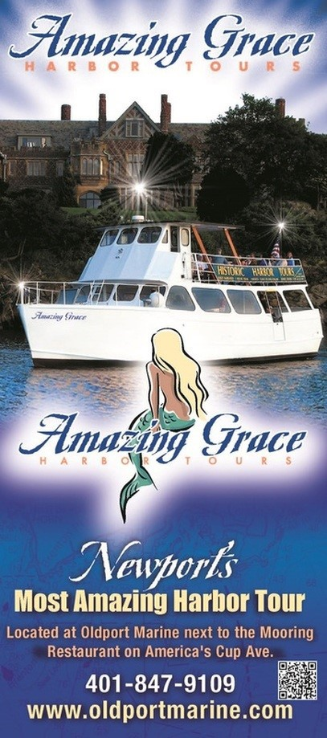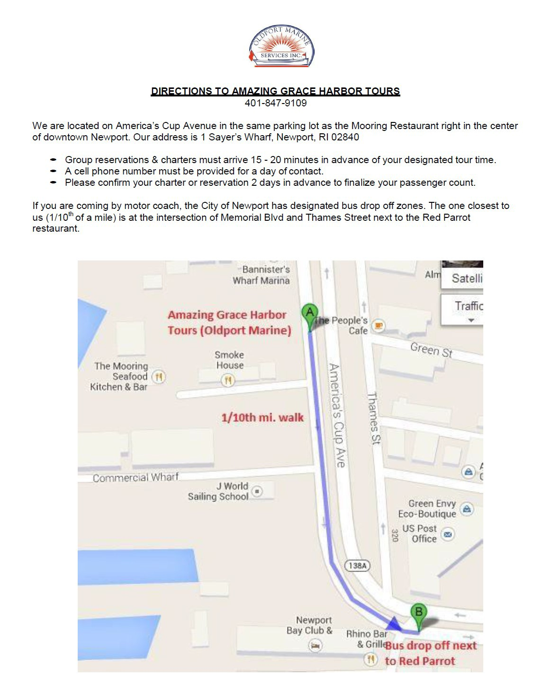

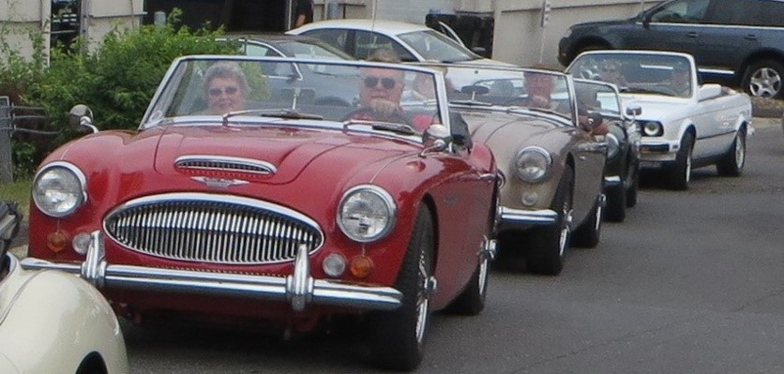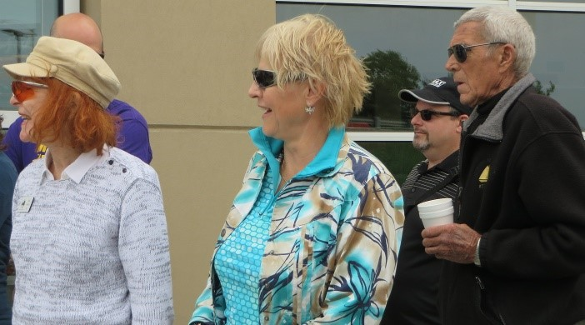The Rallye for a Cure w ill be Sunday June 12.

Rallye for a Cure
Sunday June 12, 2016
This Fun event which benefits our official charity for the past two years, the
Juvenile Diabetes Research Foundation, will begin at Jaguar Hartford in Hartford, CT. Participants will enjoy a Game-Tour-Adventure (GTA) Rallye ending with a fun filled lunch and awards ceremony at the 43rd Annual Jaguar Concours d’Elegance at Lyman Orchards in Middlefield, CT.

Proceeds raised from the $100 tax deductible per car registration will go directly to JDRF in support of its Type 1 Diabetes Research. In addition, Club Members Jud Perkins and Pat Duncan are matching each participating Club Member with an additional $50 contribution.

Pat Duncan, Dutcha
Slieker-Hersant & Doug Hersant get their instructions
at the 2015 Rallye

Len & Carolyn Bach at the 2015 start line, followed by
Jud Perkins & Pat Duncan

The registration fee includes:

- Refreshments & Coffee at Jaguar Hartford at the Start of the Rallye
- Participation in the 2016 Connecticut Vintage and Classics Sports
"Car Rallye for a Cure"
- A Delicious Lunch
- Professional Photo of your Team and Car
(photos will be available for viewing and download from this site after the event)
- Acknowledgement of your Tax-Deductible Donation
- Attendance at the Awards Ceremony immediately after the event
- Eligibility for Prizes and Awards
- Knowledge that you have helped a worthy cause!

This is a great time for wonderful cause. If you are unable to attend, I am sure that they would be happy to accept a contribution for our official charity – JDRF. Our Club is now a Bronze sponsor of the event and we look forward to great participation from all members.

If you plan on participating please, notify Jud Perkins judperk@comcast.net of your participation.

Check out Rallye website: https://sites.google.com/site/rallyeforacure/home

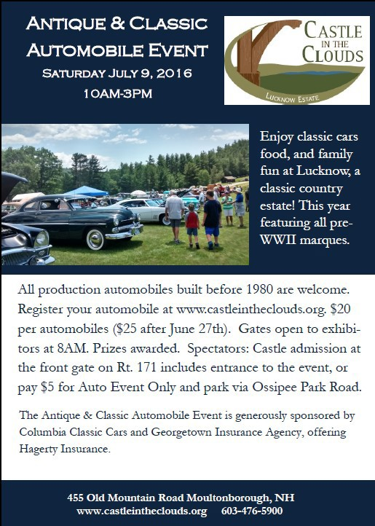
Castle in the Clouds -
Castle in the Clouds Antique & Classic Automobile Event
July 9, 2016 Moultonborough NH
Antique and Classic Automobile Event

This third annual Castle in the Clouds car show event will be held Saturday, July 9th at the grounds of this well known tourist attraction
in Moultonborough, NH.

The history of this estate, which includes the estate home, carriage house built by Thomas Plant in 1912-1914, is fascinating and the view alone is worth coming to the show for.
The event draws a large selection of pre-1980 classic European and American automobiles from around New England and benefits the restoration and continued care of this magnificent estate.

Mr. Plant was a shoe manufacturing 'mogul' at the turn of the 19th century here in New England and his built estate with features which were ahead of its time for that era. A free admission for one to visit the estate home will be included in the price of the show fee.

Plan on also visiting the restored Carriage House terrace for lunch with a spectacular view of
Lake Winnipesaukee and the mountains.

The car show will feature all marques and this year will feature pre-WW II vintage cars. British cars will have their own separate category and place on the show field. The show field is entirely grass with plenty of space to accommodate several hundred cars.
There will be door prizes, food and beverage tents, free 'jitney' bus to the estate, and awards in several car categories.

More detailed information can be found and registration can also be done online at
http://www.castleintheclouds.org

So sparkle up your Healey and come-on up to the show.
See you there. DON MARGESON
Moultonborough, NH donmrgsn@yahoo.com

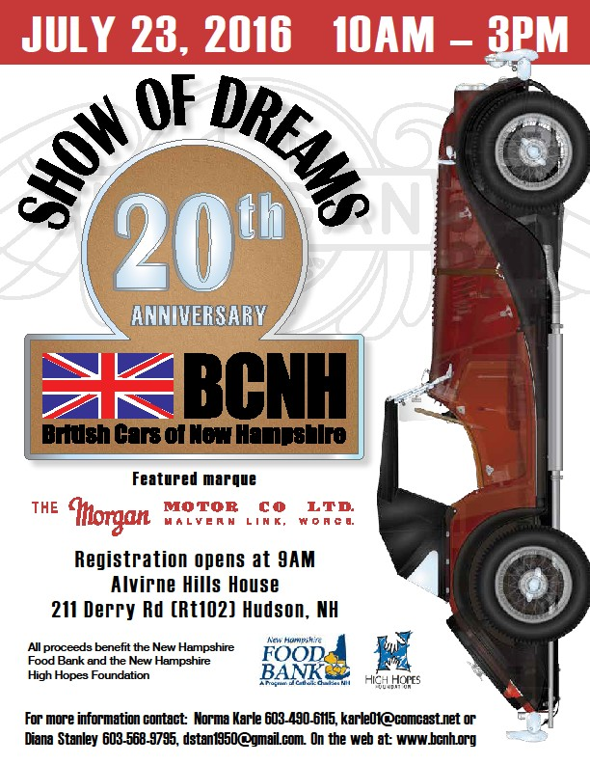
Come One, Come All
20th Show of Dreams
Alvirne Hills House—Hudson NH July 23, 2016 10AM—3PM

To British Cars of New Hampshire’s 20th Annual Show of Dreams Featured Marque : MORGAN

The Town of Hudson, NH and the Hudson Historical Society will welcome British Cars
of New Hampshire for the 20th presentation of the “Show of Dreams” to benefit High Hopes Foundation of New Hampshire and The New Hampshire Food Bank.

The event is held on Saturday, July 23, 2016 from 10am to 3pm at the Alvirne Hills House Field, 211 Derry Road (Route 102) Hudson, NH 03051.

As always, the Show of Dreams will include 25+ classes of antique, classic British cars with trophies presented in each class plus: Best in Show, Best of Featured Marque and a special prize for Diamond in the Rough.

The show field will be filled with car related vendors, craft vendors, the BCNH Tech Tent, show regalia, the BCNH Raffle & Silent Auction and Great Food. Long time friend of BCNH,
DJ Jim George, will be guiding us through
the day with information and entertainment.

The AHC-NE will be sponsoring the Austin Healey Class at the Show of Dreams.

Please join us on the field to enjoy the wonder- ful examples of British Automotive History
and support two very worthy organizations.

For further information on the charities, please visit www.highhopesnh.org and www.nhfoodbank.org.
NOTE : Pre-registration is recommended.
Car Registration : $ 25.00 Pre-Registration; $ 35.00 Day of Show Registration
$ 10.00 additional car (same owner)

Registration forms are available at : www.bcnh.org
For more information Contact Norma @ 603-490-6115 or karle01@comcast.net
Diana @ 603-568-9795 or dstan1950@gmail.com

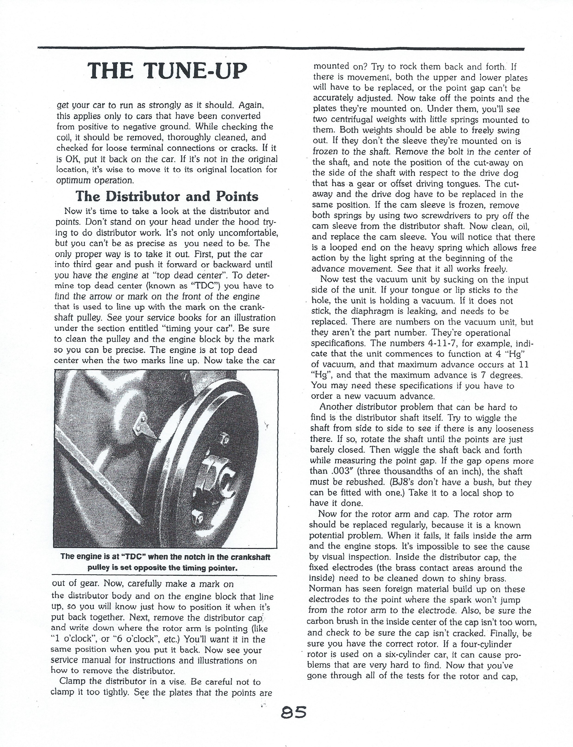

From our Technical Advisor Ted Stanton :
Here’s a timely article on tuning your engine, courtesy of an old Healey chatter issue.
Next month I will have an article on timing your car.
If there is a particular subject that you would like to see covered in this section, please let us know.

Editor’s Note : Due to space constraint, the following pages of this technical article have been reduced in size.
Please use the magnifier on your PDF-reader to see the details of this article. Thank You.

From our Technical Advisor Ted Stanton :
Here’s a timely article on tuning your engine, courtesy of an old Healey chatter issue.
Next month I will have an article on timing your car.
If there is a particular subject that you would like to see covered in this section,
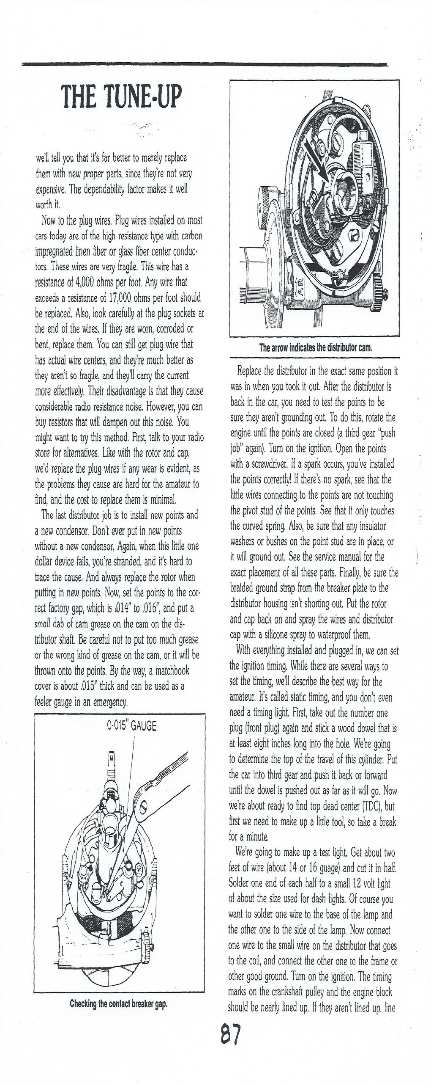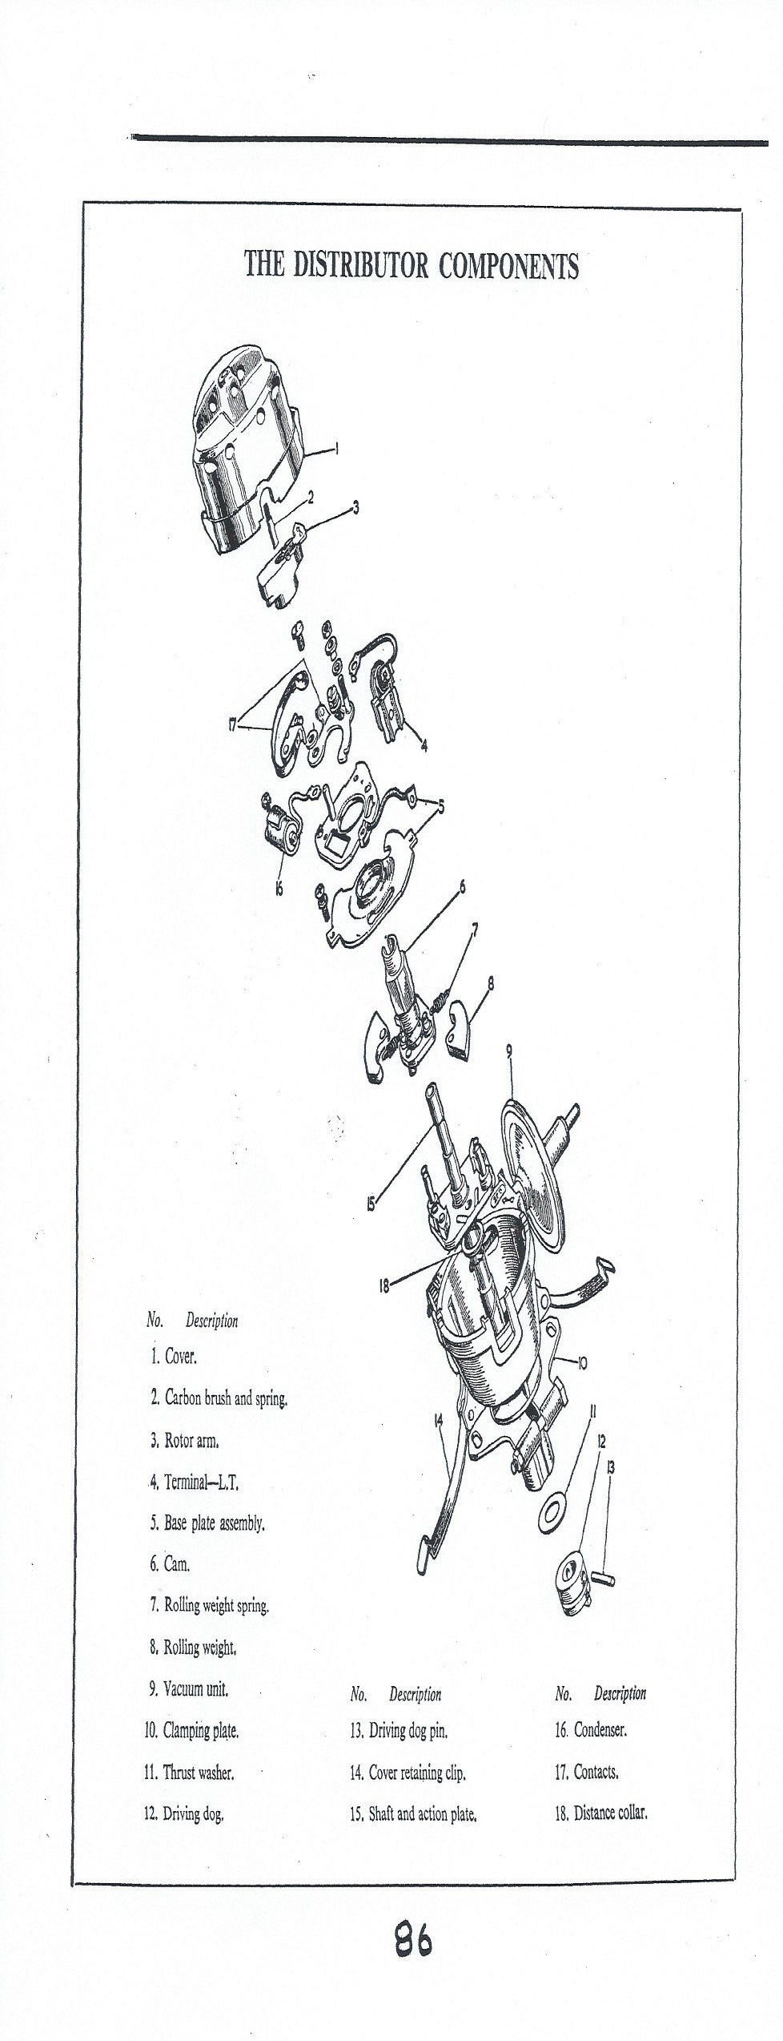

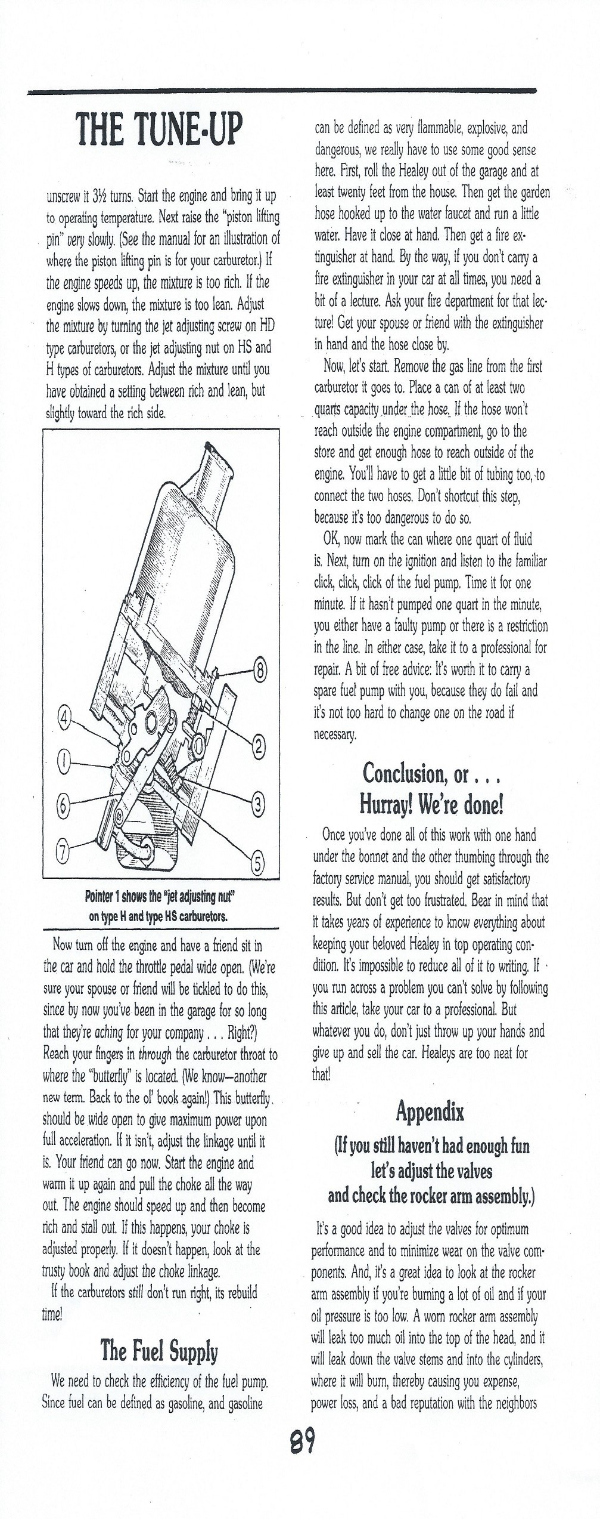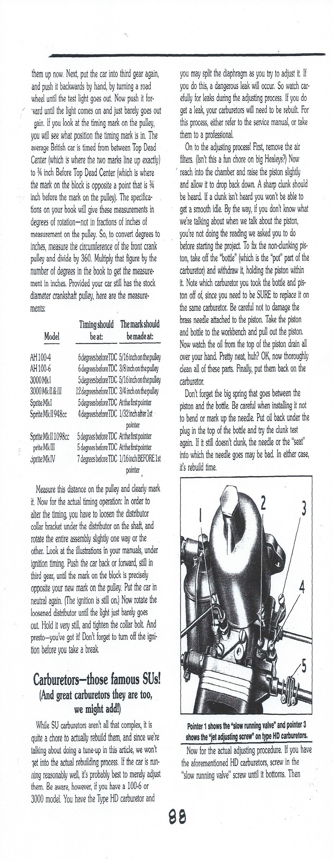

From our Technical Advisor Ted Stanton :
Here’s a timely article on tuning your engine, courtesy of an old Healey chatter issue.
Next month I will have an article on timing your car.
If there is a particular subject that you would like to see covered in this section, please let us know.

July 27-31, 2016

Mark your calendar, save the dates, fill out and return the Registration Form and book your room at the Black Bear Lodge at Stratton Mountain Resort. Stratton is one of the premier winter and summer resorts in southern VT. With its self-contained Alpine Village and majestic mountain setting Stratton is the perfect venue for Summit 2016. After you have received your registration number call Stratton Mountain Resort to book your room at the Black Bear Lodge. Rates are $119/night, double occupancy. This rate includes resort fees, VT tax and hot buffet breakfast. One and Two bedroom condos are also available in adjacent buildings for $168 and $228 night respectively, inclusive of resort fees and tax but not breakfast. Call 800-787-2886 to make your reservations and mention Summit 2016 to get this very special rate.
Down load Summit registration form here: http://www.ahca-newengland.org/summitstratton-2016.html

A preview of Summit 2016 Schedule and Events

WEDNESDAY July 27
  - Arrival, Registration and Chinese Auction Begins
  - Welcome Party
  - Dinner on your own at Black Bear Lodge, Stratton Village restaurants or other local eat- eries
  - Hospitality after dinner

THURSDAY July 28

- Explore historic Manchester Village and area attractions
- Drive your Healey up the 5.2 mile Skyline Drive auto road to the top of Mt Equinox, elev. 3848’
- Enjoy a picnic lunch at the St. Bruno Observatory at top of Mt Equinox
- Tour the historic covered bridges of Bennington County, VT
- Tour Hemming’s Motor Auto Museum and Store
- Tech Session
- BBQ dinner at Red Fox Inn, Bondville, VT

FRIDAY July 29

  - Historic VT Route 100 Rally
  - Leisure activities and time to explore the Stratton, Bromley and Manchester areas
  - Valve Cover Racing and Ice Cream Social
  - Hospitality
  - Dinner on your own in one of the many great restaurants in the Stratton/Manchester area

SATURDAY July 30

- Gymkhana and Funkhana at Stratton Mountain
- Tech Session
- Car Show on the Green
- Buffet Banquet Dinner and Awards Ceremony
- Lawn concert after dinner

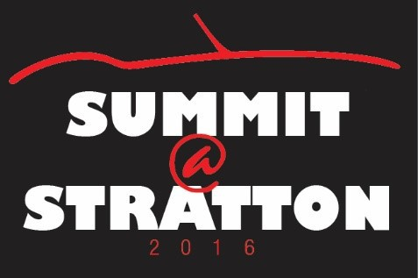 SUNDAY July 31

  - Pick up your Chinese Auction items and bid farewell to a great weekend and your Hea- ley family and friends.

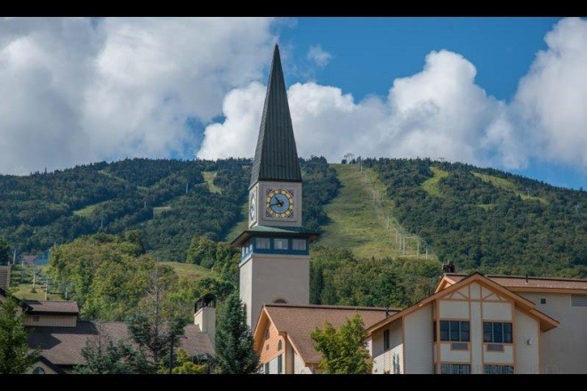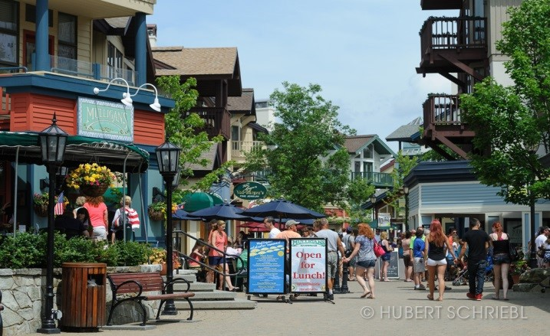

Stratton Mountain and Village

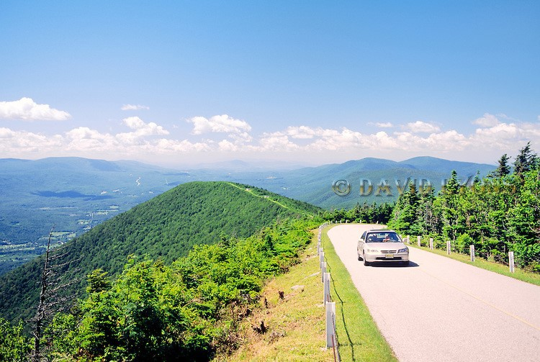
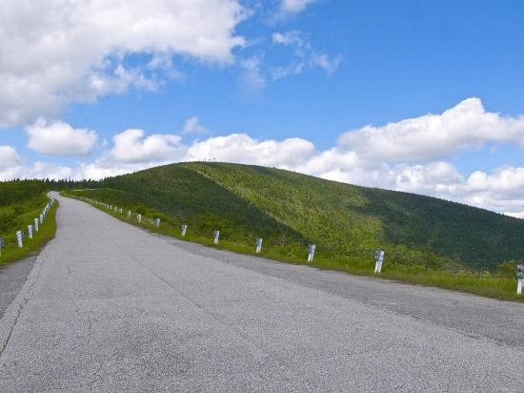

Mt Equinox Skyline Drive

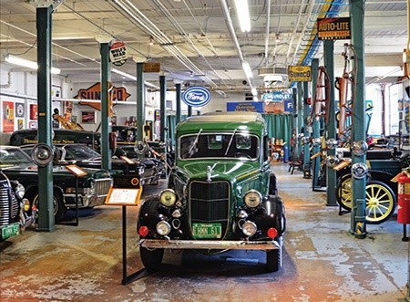
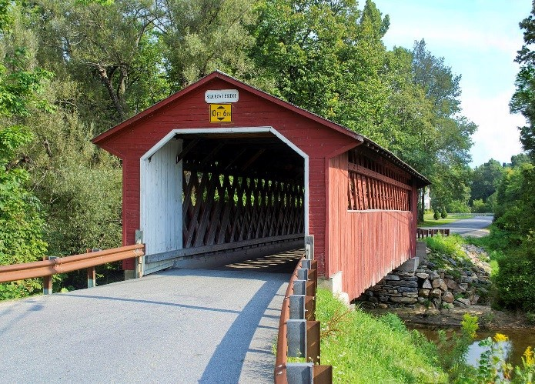

Hemmings Auto Museum One of the covered bridges on Thursday’s tour

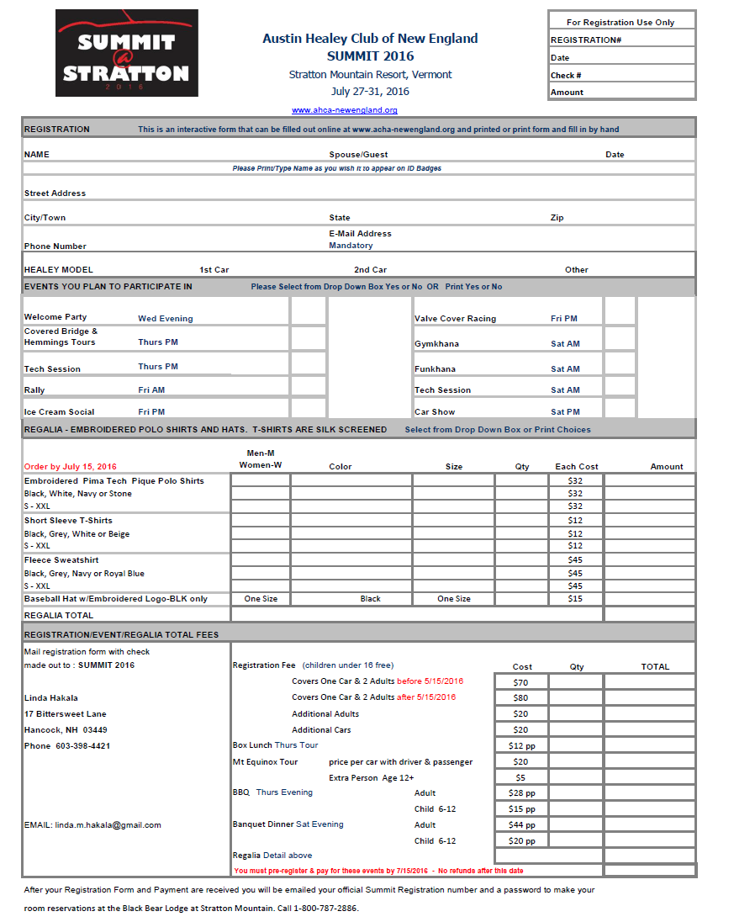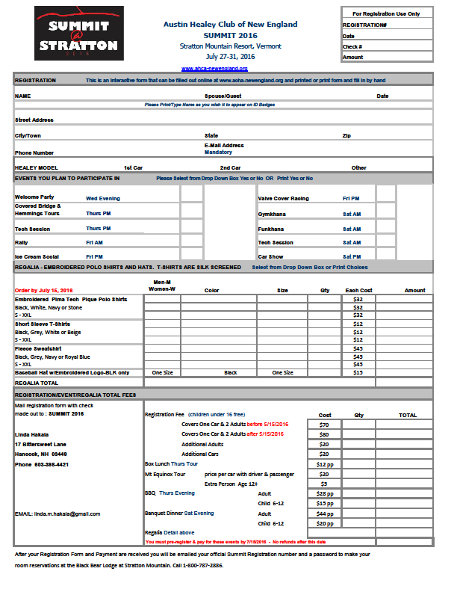

THE CLASSIFIEDS SECTION
Place a Classified Ad !
Are you trying to sell your Austin Healey or Healey Parts? You can Advertise FREE in the Healey Exhaust Notes. Every member of our club receives a copy.

Send me your ad, pictures, and your
E mail address and I will run your ad…. Dutcha Slieker-Hersant HealeyDutcha@gmail.com

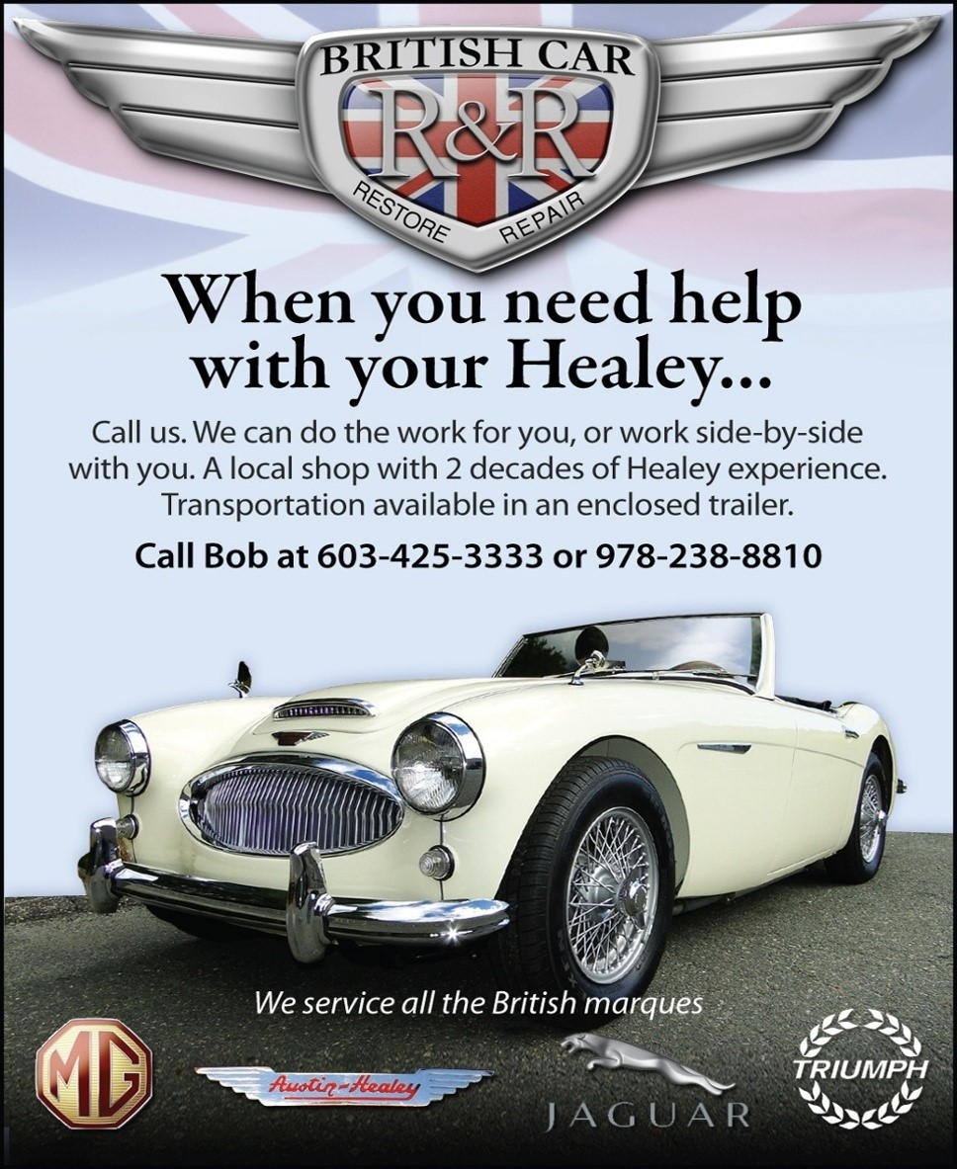

Lempert 3:53 rear end gears are all gone now. The gears now come from England.
A little more money, but still well worth the conversion for peace of mind when your Healey is on the interstate. I can replace the gears in your rear end (takes about a week) or have a rebuilt rear end ready to swap into your car in about 4 hours. The complete job is now $ 1,400.00 either way.
Also able to handle most any mechanical work your car may need to make it through the summer driving season safely. Labor rate is $ 35.00/hour. Please ask for references.

CONTACT : Paul Dunnell—Hampshire Healey; 413 339 0102; austin3000@verizon.net
Wanted BN2 / BN6 / BN7… or BJ7/8
Healey enthusiast is looking for High Quality, Driver condition Big Healey. Ultimately a BN2, BN6, BN7… or BJ7/8.
Candidates should possess a dependable reputation,
the ability to hold its fluids and a clean documentable history. Honest frames only need apply!

Please call should you have a lead.

Chip Coen at 617-962-1400 or chipcoen@live.com

THE CLASSIFIEDS SECTION

FOR SALE :
One never- mounted black Everflex repro 100 tonneau made (as original) to Roger Moment's standards. $550.

TRADE :
For a trip to Europe (or NOS 100 parts/excellent BN2 sheet metal):

One NOS early 6-cylinder right-front fender (that I've had for 48 years).

CONTACT : Rudi Markl, Rye, NY; 914 481 8555; rmarkl@optonline.net
Wanted BJ8 / BJ7

I am looking for an Austin Healey BJ8 or BJ7. I am a younger new member of the Club and would like to find a car that will fit my wife and two young boys, and will become a part of our family. I prefer a recently fully restored vehicle (within the last 10 years) but will look at older restorations to the extent they have been well-preserved and are rust-free.

I would like to find an excellent car that can be driven with pride on nice days. I live in the Boston area. Please email David at dshushan@gmail.com if you are considering selling your Healey and it fits this bill.
For Sale - 1966 3000 Mark III
$75,000
•
•
•
•
•
•
•
•
•
•
•
•
•
•
•
•

•
1966 Austin Healey 3000 Mark III
Matching Numbers - Heritage Certificate Metallic Ice Blue/Ivory Coves
Blue Interior and Top
1000 miles since complete dis-assembly and restoration Rebuilt transmission, overdrive and rear end; new 3:54 gearing All components new, rebuilt or refurbished
New 72 spoke chrome wire wheels and tires, balanced rear drums Full tonneau ,tool kit, jack, driving lights and badge bar
Finned cast alum valve cover and race oil pan 1960's Am-Fm/Aux jack Radio, plus orig.
Cockpit fully insulated
Electronic ignition; spin on oil filter Louvered and stock hood
Removable magnetic third brake light for safety.
Extra modified driver’s seat to go back an additional 2 inches and lower by 3 inches.
have all the original parts to put the car back to stock
•
I built this car to be a touring car; Health forces sale
CONTACT :
Mark Evans
203-232-3741 or Hmsevans@aol.com

THE CLASSIFIEDS SECTION

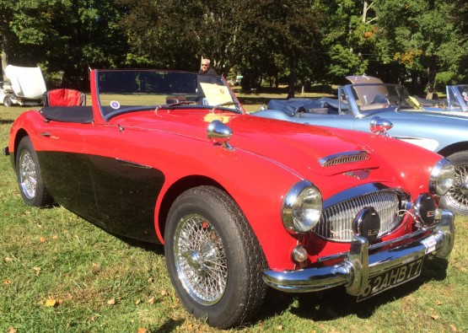
FOR SALE : 1962 BT7
$ 39,500
Beautiful older restoration with many new updated features :
- SS exhaust
- Wizard cooling system
- New gas tank
- New leaf springs / rear
- New brakes / rear
- New Dayton 72 spokes wires
- New Vredestein Spirit Classic tires
- High speed starter motor
Looks and runs great !
Tuned and ready for the nice weather. Always garaged and stored for the winter.

CONTACT :
John Houlihan
203 610 1415 or ddesigner@aol.com
For Sale : Wiring Diagrams for Austin Healeys

Prospero’s Garage, located in Rhode Island, offers wiring diagrams for sale for classic cars, trucks & bikes in factory wiring colors. Our diagrams have helped many classic car owners make their project easier with their large and easy to read color wiring diagrams.

Each diagram is 11” x 17” and laminated to keep off grease and dirt. Every classic car owner should have one for projects or just in case. Our average diagram is under $ 20.00 and looks great hung on a wall when not in use!

In addition to wiring diagrams for all Austin Healey models from 1953 to 1969, we also stock diagrams for many other classic cars, such as MG, Land Rover, Sunbeam & Jaguar.

Check out our diagrams at http://www.colorwiringdiagrams.com

THE CLASSIFIEDS SECTION

THE CLASSIFIEDS RATES

The following advertising structure was adopted at the April 2nd, 2016 Planning Meeting and takes effect with the publication of the June 2016 Healey Exhaust Notes.

Classified Ads:

AHCA-NE Members Only
Members may advertise Healey cars, parts and related services free of charge Up to 75 words max and one photo.
Ads will run for 3 consecutive issues of HEN
and must be re-submitted or renewed for additional 3 issues.

Commercial Display Ads:

Full page $ 50 monthly - $ 400 yearly / includes web link Half page $ 30 monthly - $ 340 yearly / includes web link Quarter page $ 20 monthly - $ 160 yearly
One-Eight page $ 10 monthly - $ 80 yearly
Yearly rate is based on publication of 10 issues per year and requires payment in full at time of ad placement.

The acceptance of advertising for any product or service in Healey Exhaust Notes does not imply endorsement for that product or the service by either the AHCA-NE or the AHCA.

CONCLAVE 2016
Austin Healey Club of America CONCLAVE 2016 June 12 – 17, 2016
Ohio Valley Austin Healey Club (Cincinnati) invites you to spend part of your vacation/summer driving calendar at the 2016 Healey Reunion.

Here are a few Things You Should Know about CONCLAVE 2016 :

First ….. Get out the Moss Motoring your recently received (issue 1, 2016 or http://www.mossmotoring.com/featured/) and turn to page 14.
Read the article “THIS ONE’S FOR THE LADIES” by OVAHC member Cindy Loos.
It’s a great description of what is in store for the attendees that want some other options than everything cars! Give it to your significant other for a read, especially who may be resistant or hesitant about attending a week long car thingee….

Second….. Since it is winter and cabin fever may be starting to set in, think about getting a BMC valve cover from your old parts bin or getting one from eBay and build your Valve Cover Racer for Conclave.
This is the perfect time to get prepared. We have Jim Cox who has been presiding over this event for 20+ years at the AHS&TC Encounters! We have double elimination to insure a lot of runs and a lot of fun.
Our goal was to have you complain about having too many things to do!!! Please check out the web site for the full program…
http://www.2016healeyreunion.com/index/html
The site is next to the Greater Cincinnati Airport, so if you want to fly in and ship your car (we will be happy to help coordinate on our end), the hotel will pick you up.
Please feel free to contact us with any and all questions! Email : Registration@2016HealeyReunion.com
OHIO VALLEY AUSTIN HEALEY CLUB

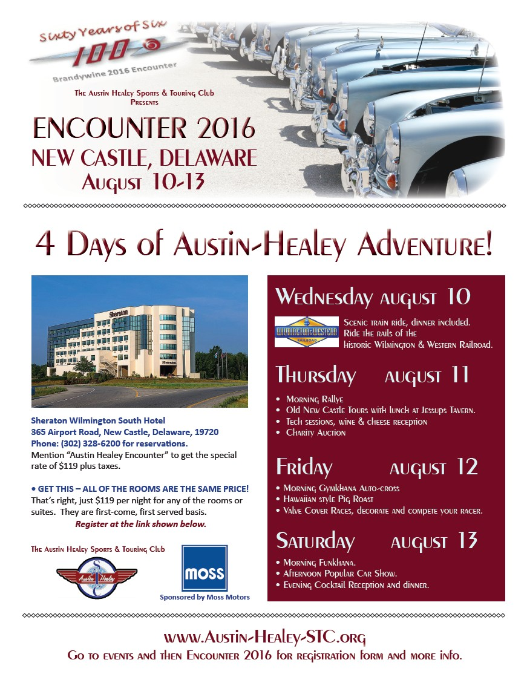

Please consider printing this form and while on your next outing with your Healey,
hand out a copy to anyone who is interested in joining the AHC-NE .

